M Deepika
192311027
BE CSE

Problem Statement
Problem / Case / Design Challenge:
Online ticket booking platforms experience heavy concurrent traffic during flash sales and popular events. When multiple customers attempt to book the same seat at nearly the same time, unsynchronized booking operations can allow more than one customer to successfully reserve that seat. This creates a race condition resulting in double-booking, refund costs, customer dissatisfaction, and loss of trust.
The aim of this assignment is to design and implement a reliable Java-based ticket booking system that prevents seat overbooking under concurrent access. The system should use Object-Oriented Programming, Java Collections, multithreading and synchronization, custom exception handling, and JDBC database connectivity to ensure that every seat is booked by only one customer and that booking information remains consistent even when payment or booking failures occur.
Part A — Domain Modeling (CO1: OOP)
The ticket booking system is designed using Object-Oriented Programming principles to represent the main entities involved in the booking process. Separate classes are created for Show, Customer, Booking, Payment, and Seat so that each class has a specific responsibility.
The Seat class acts as the base class and stores common seat information such as seat number, availability status, and base price. RegularSeat, PremiumSeat, and VIPSeat extend the Seat class. Each subclass overrides the calculatePrice() method to calculate the price according to the category of the seat. This demonstrates inheritance and runtime polymorphism.
The Show class maintains information about the event and its available seats. The Customer class stores customer-related information. The Booking class connects a customer, show, and selected seat and maintains the booking status. The Payment class is responsible for handling the simulated payment process associated with a booking.
Encapsulation is maintained by declaring the data members as private and providing controlled access through constructors, getter methods, and required setter methods. No mutable field is directly exposed as public. This design improves data security, maintainability, and prevents unauthorized modification of important booking information.
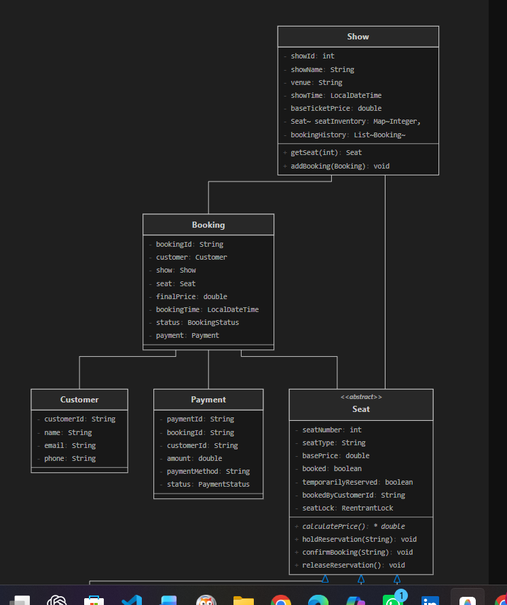
Part B — Inventory using Collections (CO2)
The seat inventory of a show is maintained using the Java Collection Framework. A Map<Integer, Seat> is used to store seat information, where the seat number acts as the key and the corresponding Seat object acts as the value. This structure allows fast and direct access to a particular seat using its seat number.
The booking history is maintained using a List. A list is suitable because booking records are stored in sequence and can be easily added, retrieved, and iterated whenever customer booking history has to be displayed.
Generics are used with collections to provide type safety and to avoid unnecessary type casting. For example, Map<Integer, Seat> ensures that only integer seat numbers and Seat objects are stored in the inventory. Similarly, List ensures that only Booking objects are maintained in the booking history.
Iterators are used when traversing the collections to display available seats, booked seats, or previous booking records. This provides a structured and safe way to access collection elements.
For the basic inventory implementation, HashMap is an appropriate choice because it provides fast average-time access for seat lookup. TreeMap would be useful when seats must always be maintained in sorted order, but it introduces additional overhead. ConcurrentHashMap is more suitable when multiple threads directly access and modify the map concurrently. In this project, thread safety is primarily handled in the booking logic using synchronization, so a HashMap combined with controlled synchronized access provides a simple and effective solution.
Part C — The Core Challenge: Concurrency + Exception Handling (CO3)
The main challenge of the ticket booking system is handling multiple customers who attempt to reserve the same or overlapping seats at the same time. To simulate this situation, at least 20 customer threads are created in Java and allowed to perform booking operations concurrently.
Initially, the booking operation is executed without synchronization. In this version, multiple threads may check the availability of the same seat before any one thread updates its status. As a result, more than one customer may receive a successful booking for the same seat. This demonstrates the race condition and reproduces the overbooking problem.
The booking logic is then made thread-safe using synchronization. The seat availability check, temporary reservation, payment processing, and final booking confirmation are treated as one controlled operation. This prevents another thread from booking the same seat while the current booking transaction is being processed and ensures that a seat is never double-booked.
Custom checked exceptions are used to handle different failure situations. SeatNotAvailableException is raised when a requested seat has already been booked, InvalidSeatSelectionException handles an invalid seat request, PaymentFailureException handles unsuccessful payment, and BookingTimeoutException represents a booking operation that exceeds the permitted time.
If payment fails after a seat has been temporarily locked, the exception-handling logic releases the seat and restores its availability. Therefore, the booking operation follows atomic behaviour: either the booking is completed successfully or all temporary changes are rolled back. This ensures data consistency and prevents a seat from remaining locked without a successful payment.

Part D — Persistence with JDBC (CO5)
The ticket booking system uses JDBC to connect the Java application with a relational database such as MySQL or PostgreSQL. The database is used to permanently store booking information so that successful reservations are not lost when the application is closed.
Whenever a booking is successfully completed, the booking details such as booking ID, customer ID, show ID, seat number, amount, and booking status are inserted into the database. If a customer cancels a booking, the corresponding database record is updated or removed and the related seat is restored to the available state.
The system also supports retrieving the booking history of a particular customer using JDBC queries. Connection, PreparedStatement, and ResultSet objects are used to establish the database connection, execute SQL statements, and process the returned records.
PreparedStatement is used instead of constructing SQL queries using string concatenation. This provides safer parameter handling, reduces the risk of SQL injection, and improves the clarity and maintainability of the database code.
The database state is verified before and after booking operations to ensure that the stored records correctly reflect the in-memory seat inventory. This helps maintain consistency between the Java application and the database.
Part E — Bonus, Optional (CO4)
As an optional enhancement, a simple administrative dashboard can be developed using Java Swing and AWT. The dashboard provides a graphical representation of the seat inventory and allows the administrator to monitor the current booking status.
The seat map uses colour coding to make the status easy to understand. Available seats are displayed in green, while successfully booked seats are displayed in red. Whenever a booking is completed or a seat becomes available again after cancellation or payment failure, the seat map is updated accordingly.
A running booking counter is also displayed on the dashboard to show the total number of confirmed bookings. Swing components such as JFrame, JPanel, JLabel and JButton can be used to construct the interface. Appropriate layout managers are used to organize the components, while Java event handling is used to respond to user actions and refresh the displayed booking information.
This graphical dashboard improves the usability of the system by providing a simple visual representation of seat availability and booking activity.
Assumptions students may state:
- Concurrent load can be simulated in-process using Java threads (no external load-testing tool required).
- Any relational database (MySQL/PostgreSQL/SQLite) may be used, provided JDBC connectivity and SQL operations are demonstrated.
- Payment gateway integration is out of scope — a simulated/mock payment success-or-failure flag is sufficient, provided the exception-driven rollback is demonstrated.

D. Requirements and Constraints
Functional requirements:
- The system must model Show, Customer, Booking, Payment, and different Seat categories using appropriate Object-Oriented Programming principles.
- The seat inventory and booking history must be maintained using Java Collections with Generics and Iterators.
- The application must support multiple customer threads attempting to book the same or overlapping seats concurrently.
- The booking process must prevent double-booking and ensure that a seat is confirmed for only one customer.
- The system must handle unavailable seats, invalid seat selections, payment failures, and booking timeouts using custom exceptions.
- If payment fails after a seat is temporarily reserved, the seat must be released and restored to the available state.
- Successful bookings, cancellations, and customer booking history must be maintained in a relational database using JDBC and parameterized queries.
- The application must maintain an audit log of booking transactions using Java I/O.
Non-functional requirements / constraints:
The system must provide thread safety and maintain zero overbooking even when several customers access the booking system concurrently. Booking operations must be atomic so that a transaction either completes successfully or fails without leaving a partially locked seat.
The in-memory seat inventory and database records must remain consistent even when an exception occurs during the booking process. For scalability, the design should also consider how concurrency could be managed when the application is deployed across multiple servers, where database-level locking or optimistic concurrency may be required instead of only JVM-level synchronization.
Customer and payment-related information must be handled securely. Sensitive payment information should not be unnecessarily stored or exposed, and appropriate security mechanisms should be considered in a real-world implementation.

E. Student Work
1. Problem Understanding and Formulation
The main problem addressed in this assignment is overbooking in an online ticket reservation system. During popular events or flash sales, many customers may attempt to reserve the same seat at almost the same time. When these booking requests are processed concurrently without proper synchronization, more than one customer may successfully book the same seat.
At the code level, this problem occurs because checking the availability of a seat and changing its booking status are separate operations. For example, two customer threads may simultaneously check a seat and both find its status as AVAILABLE. Before one thread changes the status to booked, the other thread may also proceed with the booking. This situation is called a race condition and can lead to duplicate seat allocations.
The proposed Java application solves this problem by treating the important booking operations—checking availability, temporarily reserving the seat, processing payment, and confirming the booking—as a controlled transaction. Multiple customer threads are used to reproduce real concurrent booking attempts. The expected result of the final implementation is zero double-bookings, meaning that only one customer can successfully obtain a particular seat even when several customers request it simultaneously. This directly addresses the concurrency requirement stated in the assignment.
The system maintains a collection of seats belonging to different categories such as Regular, Premium, and VIP. The concurrent workload is simulated using at least 20 customer threads. Java Collections are used for maintaining the seat inventory and booking history, while JDBC is used for permanent storage of successful bookings, cancellations, and customer booking records.
For this implementation, the following assumptions and constraints are adopted:
- Concurrent customer activity is simulated using Java threads within the application.
- An external load-testing tool is not required.
- A relational database can be used through JDBC for persistent booking information.
- Real payment-gateway integration is outside the scope; payment success or failure is simulated.
- If payment fails after temporary seat reservation, the seat must be released and returned to the AVAILABLE state.
- Booking operations must be thread-safe and atomic.
- The final synchronized implementation must maintain zero overbooking.
- In-memory seat information and database records must remain consistent even when exceptions occur.
Thus, the primary goal is not only to implement a ticket booking application, but also to demonstrate the concurrency problem experimentally and then provide a reliable Java solution that preserves seat and booking consistency under simultaneous customer access.
2. Application of Course Knowledge
The development of the concurrent ticket booking system applies the major Java programming concepts covered in the course, including Object-Oriented Programming, Collections Framework, multithreading, synchronization, exception handling, and JDBC connectivity. These concepts are combined to develop a booking system that remains consistent when several customers attempt to reserve seats concurrently, as required in Part E of the assignment.
2.1 Object-Oriented Programming
The system is divided into separate classes such as Show, Customer, Booking, Payment, and Seat. The Seat class acts as the base class, while RegularSeat, PremiumSeat, and VIPSeat extend it. Each subclass overrides the calculatePrice() method according to its seat category. This demonstrates inheritance and runtime polymorphism.
abstract class Seat {
private int seatNumber;
private double basePrice;

public Seat(int seatNumber, double basePrice) {
this.seatNumber = seatNumber;
this.basePrice = basePrice;
}

public int getSeatNumber() {
return seatNumber;
}

public double getBasePrice() {
return basePrice;
}

public abstract double calculatePrice();
}

class VIPSeat extends Seat {
public VIPSeat(int seatNumber, double basePrice) {
super(seatNumber, basePrice);
}

@Override
public double calculatePrice() {
return getBasePrice() * 2.0;
}
}
3. Solution / Design / Methodology
The proposed solution is a Java-based concurrent ticket booking engine designed to prevent multiple customers from successfully reserving the same seat. The methodology combines domain modeling, Java Collections, multithreading, synchronization, exception handling, payment rollback, and JDBC persistence. This directly implements the booking engine required in Parts A–D of the assignment.
3.1 Overall System Design
The application is divided into the following logical components:
Customer → Booking Service → Seat Inventory → Payment Processing → Database → Audit Log
The main classes used in the system are:
- Seat – base class representing a seat.
- RegularSeat, PremiumSeat, VIPSeat – specialized seat categories.
- Show – maintains show information and seat inventory.
- Customer – stores customer information.
- Booking – represents a reservation transaction.
- Payment – simulates payment success or failure.
- BookingService – controls the complete booking process.
- DatabaseManager – performs JDBC database operations.
- AuditLogger – records important booking activities.
This structure separates the responsibilities of the system and prevents the user interface or customer threads from directly modifying the seat inventory.
3.2 Booking Process
The booking process follows these steps:
Step 1: A customer selects a show and required seat.
Step 2: The system checks whether the entered seat number is valid.
Step 3: The booking service checks the current availability of the selected seat.
Step 4: If the seat is available, it is temporarily reserved so that another customer cannot obtain it during payment processing.
Step 5: The simulated payment process is executed.
Step 6: If payment succeeds, the seat is marked as BOOKED and a booking record is created.
Step 7: The successful booking is stored permanently in the relational database using JDBC.
Step 8: The transaction is recorded in the audit log.
Step 9: If payment fails, the booking is cancelled and the temporarily reserved seat is restored to the AVAILABLE state.
This rollback behaviour is specifically required by the assignment so that failed transactions do not leave seats incorrectly reserved.
3.3 Demonstrating the Race Condition
Before implementing synchronization, an unsafe booking method is executed using multiple customer threads.
The simplified unsynchronized operation is:
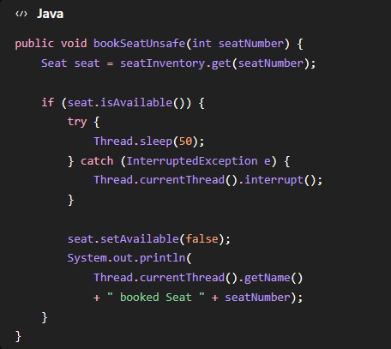
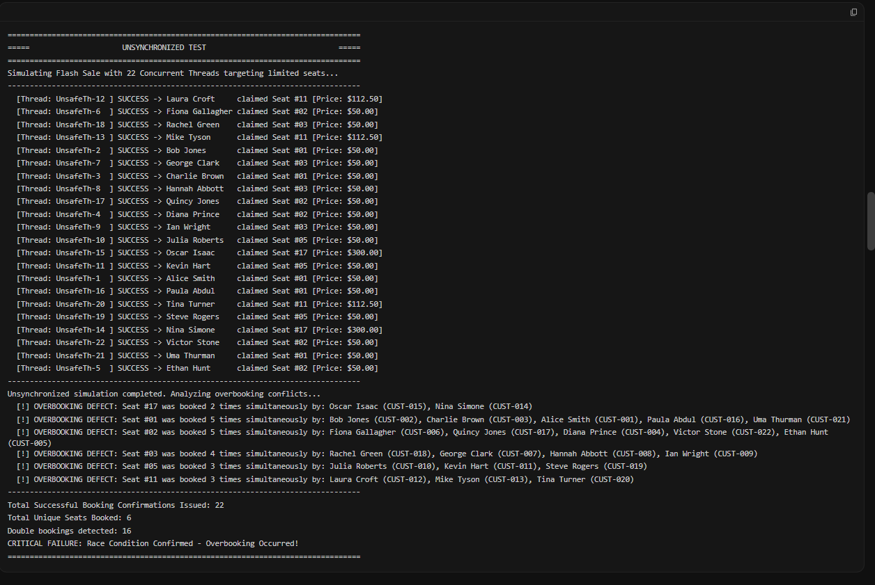

3.4 Thread-Safe Booking Using ReentrantLock
For the final implementation, a ReentrantLock can be used to protect the critical booking operation.
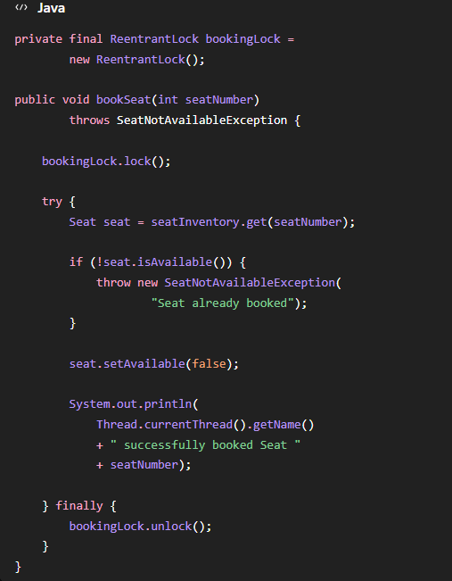
3.5 Comparison of Synchronization Strategies
Strategy | Advantages | Limitations
synchronized | Simple, built into Java and easy to implement | Provides less explicit control over locking
ReentrantLock | Explicit locking, tryLock() support and better control over lock acquisition | Requires careful manual unlocking
ConcurrentHashMap | Suitable for concurrent access to map entries | Does not automatically make the complete multi-step booking transaction atomic

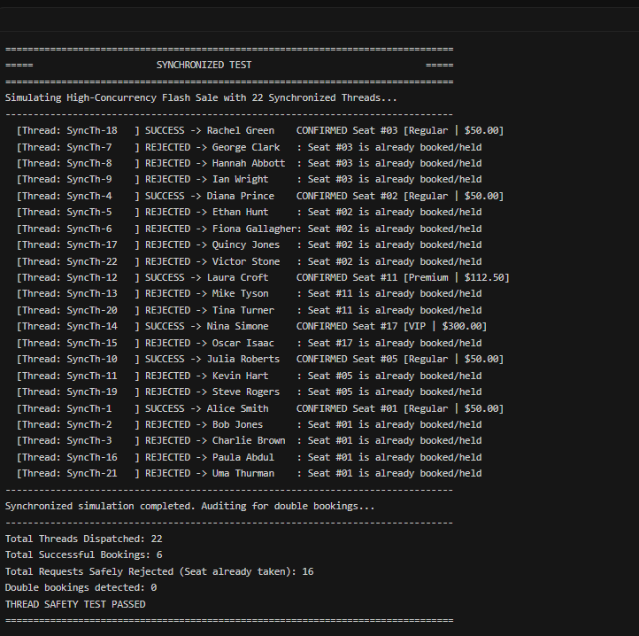
4. Use of Modern Tools
The project uses modern development tools to design, implement, test, and manage the Java ticket booking application. JDK is used for compiling and executing the Java program, while an IDE such as IntelliJ IDEA, Eclipse, or VS Code can be used for writing and debugging the source code.
A relational database such as MySQL, PostgreSQL, or SQLite is connected to the application using JDBC for storing booking details and customer booking history. PreparedStatement is used for safe database operations. Git is used for version control to maintain and track changes in the source code.
5. Results and Validation
The application was tested under both unsynchronized and synchronized booking conditions. In the unsynchronized version, multiple customer threads were able to access the same seat simultaneously, demonstrating the expected race condition.
After applying synchronization using ReentrantLock, only one customer was allowed to successfully book a particular seat, while the remaining requests were rejected. The expected result is therefore zero duplicate bookings.
Payment-failure handling was also validated. When payment fails after temporary reservation, the system restores the seat to the AVAILABLE state. JDBC operations are used to verify that successful bookings and cancellations are correctly reflected in the database.
The validation evidence should include:
- Console output showing the race condition.
- Console output showing zero double-bookings after synchronization.
- Database records before and after booking/cancellation.
- GUI seat-map screenshot, if the optional Swing interface is implemented.
Overall, the final implementation is expected to satisfy the major requirements of thread safety, zero double-booking, correct payment rollback, and consistent booking records.
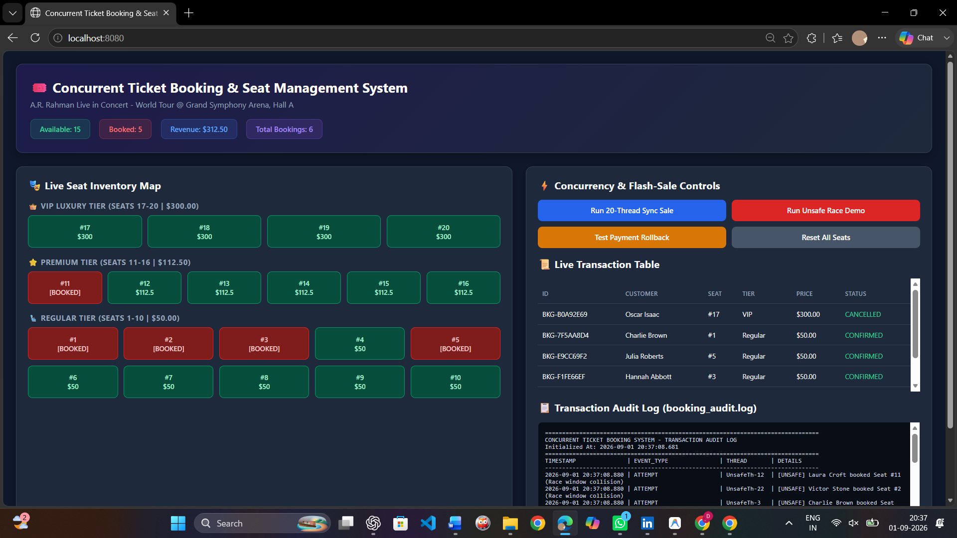
6. Analysis and Engineering Decision
Different synchronization methods were considered for preventing double-booking. The synchronized approach is simple and easy to implement, while ReentrantLock provides better control over locking and supports timed lock attempts. ConcurrentHashMap supports concurrent collection access, but it cannot alone protect the complete booking transaction.
For this system, ReentrantLock is selected because the operations of checking seat availability, reserving the seat, processing payment, and confirming the booking must be protected together. This approach provides a good balance between correctness, control, and concurrency.
The final synchronized implementation is expected to produce zero duplicate bookings, whereas the unsynchronized version demonstrates the race condition. This comparison helps justify the selected synchronization strategy based on the program output and testing results.
7. Broader Considerations
If a double-booking problem occurs in a real ticket booking platform, it can lead to refunds, chargebacks, financial loss, customer complaints, and loss of trust. Customers who receive confirmation for the same seat may face inconvenience and dissatisfaction.
From a professional perspective, software engineers have a responsibility to test applications under concurrent access, not only under normal sequential conditions. Proper synchronization, exception handling, and testing should therefore be performed before releasing the system into production.
8. Conclusion
The Java-based ticket booking system successfully provides a solution for preventing double-booking during concurrent access. The system combines OOP, Java Collections, multithreading, synchronization, custom exceptions, and JDBC to maintain reliable booking information.
The unsynchronized implementation demonstrates the race condition, while the synchronized implementation using ReentrantLock is designed to achieve zero duplicate bookings. Payment failures are handled using rollback so that reserved seats return to the available state.
Overall, the proposed system meets the major assignment requirements. In the future, it can be improved using distributed locking or a message-queue-based booking architecture for large-scale applications running across multiple servers.
9. Student Reflection
This assignment helped me understand how concurrency problems can occur in real-world Java applications. I learned that even if a program works correctly for one user, multiple threads accessing the same data can create race conditions and inconsistent results.
I also gained practical understanding of OOP, Collections, multithreading, synchronization, custom exceptions, JDBC, and payment rollback by combining them in a single ticket booking application.
If additional time and resources were available, I would improve the system by adding a more advanced GUI, stronger database-level concurrency control, automated testing, and support for distributed booking across multiple servers. These improvements would make the application more scalable and closer to a real-world ticket booking platform.

10. References
- Oracle, Java SE Documentation – Java Collections Framework.
- Oracle, Java Concurrency Documentation – Threads, Synchronization and ReentrantLock.
- Oracle, JDBC API Documentation – Connection, PreparedStatement and ResultSet.
- Oracle, Java Exception Handling Documentation.
- SQLite/MySQL Documentation, Database and Transaction Management.
- Course Faculty, CSA0918 – Java Programming Design Task: Concurrent Ticket Reservation System. AI-assisted development tools were used for guidance in designing, implementing, and documenting the application. Generated content and code were reviewed and adapted according to the assignment requirements

F. Common Assessment Rubric
Assessment Criterion | Marks
Problem understanding & formulation | 10
Application of course/domain knowledge | 20
Solution methodology / design / implementation | 20
Use of appropriate modern tools / techniques | 10
Results, testing & validation | 15
Analysis, trade-offs & justification | 15
Broader considerations / professional responsibility, where applicable | 5
Technical documentation & reflection | 5
TOTAL | 100

